A

Seminar Report on

**“Google’s Willow Quantum Chip “**

At



**GIDC RAJJU SROFF ROFEL INSTITUTE OF MANAGEMENT OF STUDIES (BBA) &**

**ROFEL SHRI G.M BILAKHIA COLLEGE OF APPLIED SCIENCES (BCA), VAPI**

**[ISO 9001:2015, 29990-2010 Certified College]**



**Affiliated to**

**Veer Narmad South Gujarat University, Surat**

As a partial fulfilment

For the degree of

Bachelor of Computer Application

(B. C. A.)

2024-2025

**Guided By:** **Submitted By:** Prof. Kinjal Patel Adarsh Prajapati

**CERTIFICATE**

**Acknowledgement**

I take this opportunity to thank all those who have contributed their support in preparing this Seminar. Firstly, I would like to express my deep sense of gratitude towards ROFEL, Shri G.M. Bilakhia College Of Applied Sciences (BCA), Vapi.

Providing me this opportunity to implement the theoretical knowledge into practical work as part of project in sixth semester course curriculum.

I would not miss the opportunity to thank my project guide **Prof. Kinjal Patel** who has always provided continuous guidance & support and always been a stepping stone in completing this project without her/his assistance this would have not been possible.

I am also very thankful to Principal **Dr. P.H.Ved** of our college for his keen interest and for providing all facilities in my project work.

Last but not least, I am also grateful to my parents and friends whose continuous support has always boosted my/our moral towards working on this project & I am also grateful to the co-operation of our company project guide **Prof. Kinjal Patel**, without their sincere guidance this project would not have been possible.

|  |  |  |
| --- | --- | --- |
| **Index** | | |
| **Sr. No** | **Introduction** | **Page No** |
| 1. | Introduction to Quantum Computing | 5 |
| 2. | What is Willow? | 7 |
| 3. | Key Features of Willow | 8 |
| 4. | **Bits vs Qubits: A Simple Comparison** | 9 |
| 5. | Real-World Applications | 10 |
| 6. | Benchmark Performance | 12 |
| 7. | Quantum Error Correction | 13 |
| 8. | Comparative Analysis: Willow vs. Supercomputers | 14 |
| 9. | Challenges and Future Scope | 15 |
| 10. | Vision for Quantum Computing | 17 |
| 11. | Conclusion | 18 |
| 12. | Bibliography | 19 |

**1.Introduction to Quantum Computing**

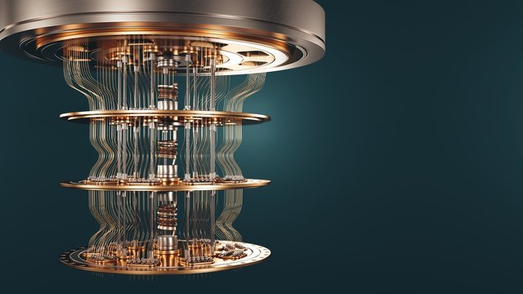

• **Fundamentals:**

* Quantum computing is a paradigm shift from classical computing, leveraging the principles of quantum mechanics.
* Classical computers use bits (0 or 1), while quantum computers use qubits, which can exist in a superposition of both states simultaneously.
* Another key concept is entanglement, where qubits become correlated, allowing for complex calculations.
* These quantum phenomena enable quantum computers to tackle problems that are intractable for classical computers.

• **Applications:**

* Drug discovery and materials science: Simulating molecular interactions.
* Cryptography: Developing secure communication protocols.
* Optimization: Solving complex optimization problems in logistics, finance, and AI.
* Artificial intelligence: Enhancing machine learning algorithms.

**History of Quantum Computer**

The history of quantum computing dates back to the theoretical foundations of quantum mechanics itself, with its practical realization emerging in the late 20th century.

After the development of quantum mechanics in the early 20th century, the first theoretical exploration of quantum computation began in the 1980s. In 1980, Paul Benioff conceptualized a quantum Turing machine, which was intended to demonstrate the theoretical possibility of quantum computation. In 1982, Richard Feynman proposed that quantum systems could be efficiently simulated by quantum computers, highlighting the limitations of classical computers for this task. In 1985, David Deutsch described a universal quantum computer, proving that a quantum computer could perform any computable task.

In the 1990s, the first significant quantum algorithms were developed. In 1994, Peter Shor introduced Shor's algorithm, which demonstrated the potential of quantum computers to efficiently factor large numbers, a task that is computationally intractable for classical computers. In 1996, Lov Grover developed Grover's algorithm, which provided a quadratic speedup for searching unsorted databases. These algorithmic breakthroughs spurred intense research into the physical implementation of quantum computers.

In the late 1990s and early 2000s, the first experimental quantum computers were built. In 1998, the first 2-qubit NMR quantum computer was demonstrated, marking a significant milestone in the physical realization of quantum computation. In the early 2000s, various technologies for building qubits, including superconducting circuits and trapped ions, began to emerge. Since then, many research groups and companies have developed various types of Quantum computers.

In 2011, D-Wave Systems released the first commercially available quantum computer, although its quantum nature and practical applications were debated. In 2019, Google claimed to have achieved quantum supremacy, demonstrating that a quantum computer could perform a specific task faster than the most powerful classical supercomputers. Since then, many companies and research groups have invested heavily into the research and development of quantum computers, and the field is rapidly advancing.

**2.What is Willow?**

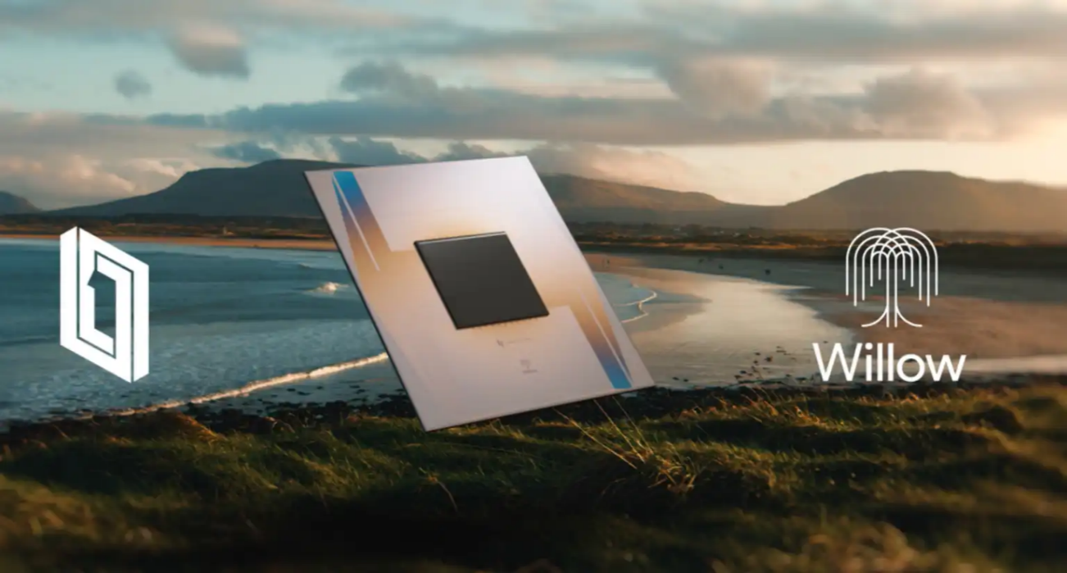

* Willow is a quantum chip developed by Google in 2024.
* It is much faster, smarter, and more efficient at fixing errors than older chips.
* Willow’s speed is unbelievable! it can solve a problem in under 5 minutes, while a supercomputer would take 10 septillion years (10²⁵ years)—much longer than the age of the universe!

**Main Features:**

1. It has over 105 qubits for processing complex calculations.
2. It has a special cooling technique to keep qubits stable.
3. It's designed to solve real-world problems in medicine and security and more .

**3.Key Features of Willow**

• **Error Correction:**

* A primary focus of Willow is improved quantum error correction. Quantum systems are inherently fragile, and errors are a major challenge.
* Willow has advancements that greatly reduce errors, which is a key component to creating a usefull quantum computer.

• **Scalability:**

* Willow is designed to be scalable, meaning it can be built with increasing numbers of qubits while maintaining performance.

• **Superconducting Qubits:**

* It uses superconducting transmon qubits, a technology Google has been developing for years.
* These qubits operate at extremely low temperatures, close to absolute zero.

• **Performance Benchmarks:**

* Willow has displayed very high performance in random circuit sampling (RCS) benchmarks.

**4.Bits vs Qubits: A Simple Comparison**

**Introduction**

Computers process and store information using basic units of data. In classical computers, we use **bits**, whereas in quantum computers, we use **qubits**. This document explains the key differences between bits and qubits in a simple and easy-to-understand way.

**1. What is a Bit?**

* A **bit (binary digit)** is the smallest unit of data in a classical computer.
* A bit can have only **two values: 0 or 1**.

**Example:**

* If a computer stores the number **5**, it does so in binary as **101** (where each digit is a bit).
* Bits are used in all modern computing devices like laptops, smartphones, and servers.

**Limitation of Bits:**

Bits process information **one at a time**.

If we need to perform a large calculation, the computer must go step by step, making complex tasks slow.

**2. What is a Qubit?**

* A **qubit (quantum bit)** is the fundamental unit of data in a quantum computer.
* Unlike bits, qubits can be **0, 1, or both at the same time (superposition)**

**Example:**

* A bit can be either **0 or 1**.
* A qubit can be **0, 1, or 50% of both at the same time**!
* Qubits exist due to the principles of **quantum mechanics**, making quantum computers powerful for certain tasks.

**Advantage of Qubits:**

* Because of **superposition**, quantum computers can process multiple calculations at once.
* This makes quantum computers much faster than classical computers for specific problems.

**5.Real time application**

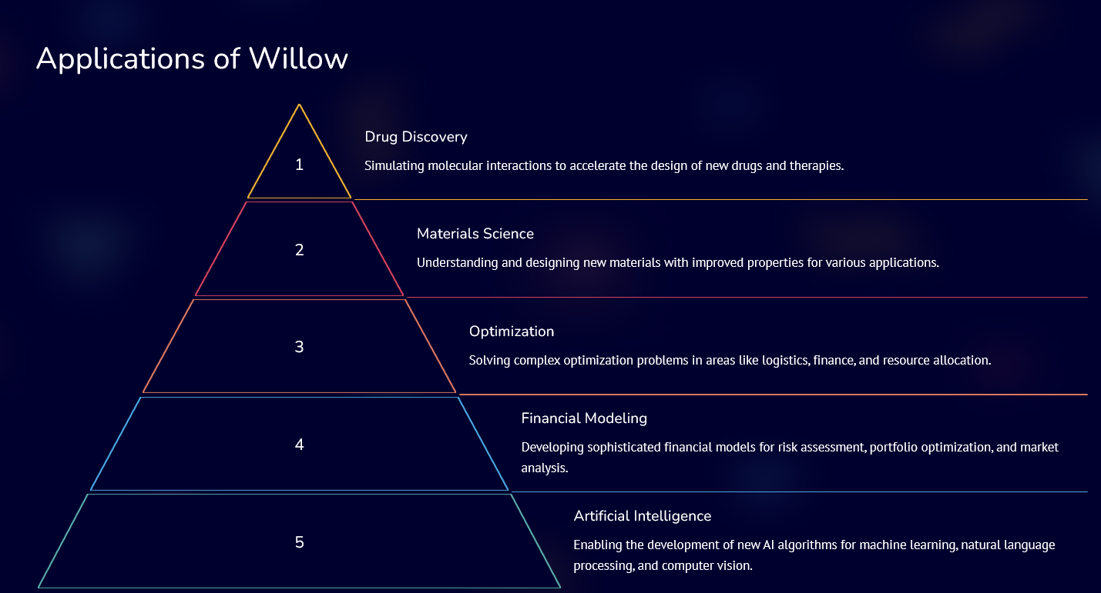

The **Google Willow Quantum Chip** is still in the development phase, so its real-time **commercial** use is currently limited.

Some key fields where the Willow Quantum Chip is being used are below.

1. **Drug Discovery (Pharmaceutical Research)**

* Google has partnered with pharmaceutical companies like **Pfizer and Biogen** to use quantum computing for **molecular simulations**.
* The **high-speed quantum calculations** of the Willow chip help simulate **complex protein folding and drug molecule interactions**.  
  This research is accelerating the development of new drugs for diseases like **Alzheimer’s and cancer**.

**2. Quantum Cryptography & Cybersecurity**

* Google is working with **NIST (National Institute of Standards and Technology)** to develop **quantum cryptography algorithms**.
* The **Willow Quantum Chip** is being used to advance **post-quantum encryption**, ensuring future-proof **cybersecurity**.
* Quantum-resistant encryption is already being tested in **banking and data security** applications.

**6.Benchmark Performance**

• Google has reported that Willow achieved a significant milestone in benchmark testing.

• Specifically, in random circuit sampling (RCS) benchmarks, Willow performed calculations in minutes that would take classical supercomputers an astronomically long time.

• This demonstrates the potential for quantum advantage, where quantum computers can outperform classical computers on specific tasks.

• The comparison to the amount of time it would take super computers to do the same task is meant to show the massive increase in speed.

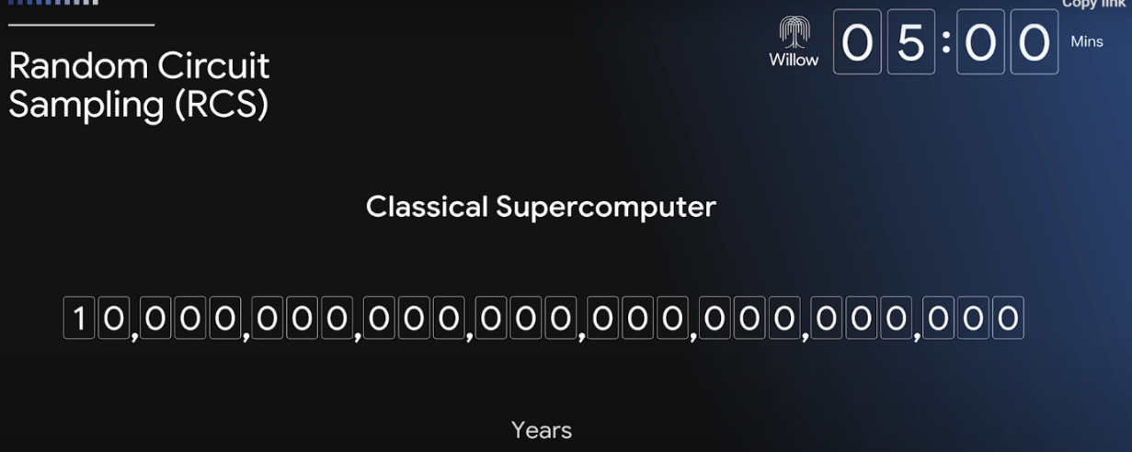

* **Unmatched Speed:**
  + Solved a computation in just 5 minutes that traditional supercomputers would take billions of years to complete.
* **Real-World Example:**
  + Simulated molecular interactions to aid drug discovery, significantly reducing research timelines for pharmaceutical development.
* **Energy** **Efficiency**:
  + Demonstrates lower energy consumption compared to supercomputers, making it environmentally friendly.

**7.Quantum Error Correction**

* Why is it Important?
  + Qubits are very sensitive and can lose information easily.
* How Willow Handles It:
  + Uses a new method to detect and fix errors quickly.
* Results:
  + Can work with more qubits without errors messing up the process.

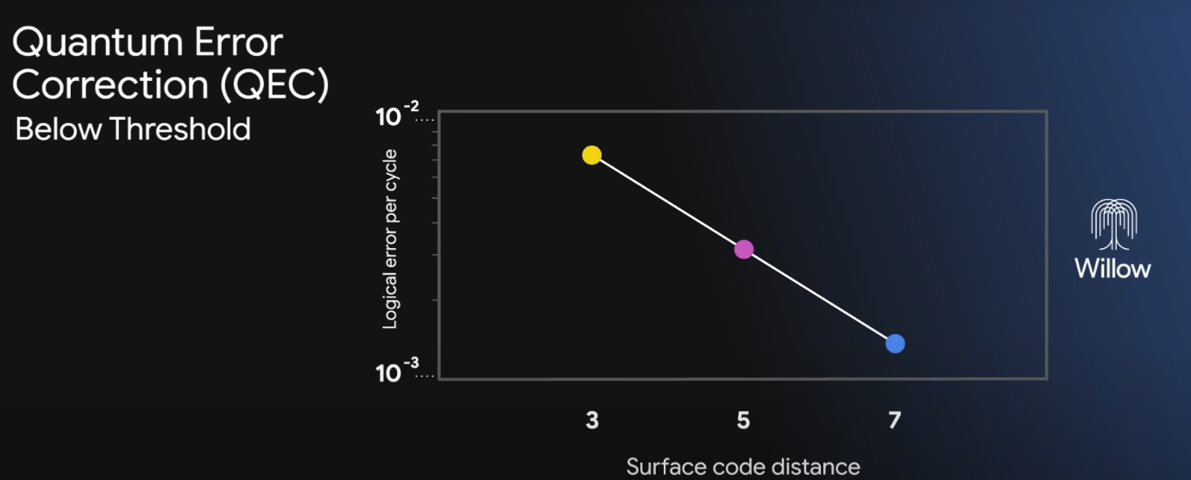

**8.Comparative Analysis: Willow vs. Supercomputers**

**Willow**

* Quantum Bits (Qubits): Willow Quantum Chip uses qubits, which process multiple possibilities simultaneously.
* Low Power Consumption: Quantum computers like Willow consume relatively low power to operate
* Cryogenic Cooling: Quantum computers like Willow require cryogenic cooling.

**Super Computer**

* Classical Bits: Supercomputers use classical bits, For processing information sequentially.
* High Power Consumption: Supercomputers require significant power to operate.
* Air or Liquid Cooling: Supercomputers use air or liquid cooling systems.

**9. Challenges and Future Scope**

Quantum computing is a revolutionary technology, but it still faces several challenges before it can be widely adopted. Researchers and companies are actively working to overcome these obstacles and unlock its full potential.

**Challenges**

1. **Very Expensive to Build**
   * Quantum computers require highly specialized materials and infrastructure, such as ultra-cold environments (near absolute zero) and advanced superconducting circuits.
   * The cost of maintaining a quantum system is significantly higher than traditional computers, making it difficult for smaller organizations to invest in quantum technology.
2. **Keeping Qubits Stable for Long Periods is Hard**
   * Qubits are extremely fragile and easily affected by temperature changes, electromagnetic interference, and vibrations.
   * This instability leads to errors in computations, requiring advanced **quantum error correction** methods, which themselves demand even more qubits.
3. **Limited Software Available for Quantum Systems**
   * Unlike classical computers, quantum systems require specialized programming languages and algorithms, which are still being developed.
   * There is a shortage of skilled quantum programmers, making it challenging to build software that can fully utilize quantum capabilities.
   * Companies like IBM, Google, and Microsoft are working on developing user-friendly quantum software frameworks, but the field is still in its early stages.

**Future Scope**

1. **Work with Industries to Create Real-World Solutions**
   * Quantum computing has the potential to revolutionize industries like healthcare, finance, cryptography, and artificial intelligence.
   * Companies and researchers are collaborating to develop quantum algorithms for solving real-world problems such as drug discovery, fraud detection, and climate modeling.
   * As more industries recognize its benefits, we can expect greater investments and advancements in quantum research.
2. **Add More Qubits and Improve Their Stability**
   * Increasing the number of qubits in a quantum computer will allow for more powerful computations.
   * Current quantum computers have around 1,000 qubits, but future models aim to reach millions of qubits.
   * Scientists are also working on making qubits more stable and resistant to errors, which will lead to more reliable quantum processors.
3. **Combine Quantum and Regular Computing**
   * Instead of replacing classical computers, quantum computers will work alongside them to tackle specific complex problems.
   * Hybrid computing systems will use quantum computers for tasks like optimization and machine learning while relying on traditional processors for simpler operations.
   * This approach will make quantum computing more accessible and practical for businesses and researchers.

**10.Vision for Quantum Computing**

In the immediate future, the focus is on addressing technical challenges and making quantum computing more practical and accessible:​

**Enhancing Qubit Stability and Error Correction:** Qubits, the fundamental units of quantum information, are highly sensitive to environmental factors, leading to errors in computations. Researchers are developing advanced error correction techniques and more stable qubit designs to improve reliability. ​

**Scaling Quantum Systems:** Efforts are underway to increase the number of qubits in quantum processors. For instance, companies like IBM and Atom Computing have announced quantum computers with over 1,000 qubits, aiming to handle more complex computations. ​

**Developing Hybrid Quantum-Classical Systems:** Integrating quantum processors with classical computing systems allows for tackling specific problems more efficiently, leveraging the strengths of both paradigms. ​

**Exploring Early Applications:** Identifying and developing algorithms for near-term applications in fields such as cryptography, optimization, and material science to demonstrate quantum advantage in practical scenarios. ​

Long-Term Vision

The overarching goal is to achieve large-scale, fault-tolerant quantum computing with widespread applicability:​

**Building Universal Quantum Computers:** Developing machines capable of solving a broad range of problems across various domains, outperforming classical supercomputers in tasks like complex simulations and large-scale data analysis. ​

**Advancing Quantum Networking:** Establishing quantum communication networks to enable secure data transmission and the development of a quantum internet, enhancing cybersecurity and enabling new forms of information sharing.

**Democratizing Quantum Technology:** Making quantum computing resources accessible to a broader audience through cloud platforms and affordable hardware, fostering innovation and education in the field. ​

**Transforming Industries:** Applying quantum computing to revolutionize sectors such as healthcare, finance, and logistics by providing solutions to problems currently deemed intractable.

**11.Conclusion**

The **Willow chip** is an advanced quantum chip that uses **qubits** instead of normal computer bits, making it much more powerful for certain tasks.

It can solve **complex problems faster** than traditional supercomputers.

The chip has important features like **quantum error correction** and high performance, making it useful for fields like **security, artificial intelligence, and scientific research**.

There are still **challenges**, such as **keeping qubits stable** and reducing errors, which need to be solved for large-scale use.

Despite these challenges, the **Willow chip is a big step forward** in quantum computing.

Scientists and engineers are working on **improving the technology**, making it more reliable and accessible.

In the future, **quantum chips like Willow could change the way computers work and solve problems beyond the reach of today’s technology.**

**Bibliography**

1. Google’s Blog on Willow: [https://blog.google/technology/research/google-willow-quantum-chip/ ]
2. Research Articles on Quantum Computing
3. Meta ai
4. Gemini ai
5. Chat GPT
6. Blackbox ai for image generation